

PubPol 587

**Leadership Skills for Mission-Driven Organizations**

Winter 2024

**Faculty:** Brian Flanagan

**Contact:** [btflan@umich.edu](mailto:btflan@umich.edu)

**Office Hours:** By appointment via Zoom

**OVERVIEW**

Today's organizations face more volatility, uncertainty, complexity, and ambiguity than ever before. This "VUCA" reality is well documented and understood by senior leaders, who are responsible for responding to rapid change in dynamic work environments. Advice abounds, as do frameworks and analytical tools that help organizations gather data, strategize, and adapt to disruptions.

This external, strategic focus is vitally important if organizations want to survive in the 21st century. And yet, to quote the cult classic film, *Shawshank Redemption*, "salvation lies within." For organizations around the globe, the greatest antidote to the VUCA environment is their people. Led well, people are a profound source of collective vision, strength, and ingenuity.

In this course, we will look at mission-driven organizations through the lens of their essential ingredient: human beings. We'll review the empirical evidence and consult your experience. We’ll see that effective leaders balance the need to get stuff done with a strong commitment to engaging and unleashing their people. We’ll explore how they honor and humanize the workplace, bringing out the best in their teams by doing everything in their power to create:

* **Clarity** — about who we are, where we're going, and how
* **Vitality** — built on intrinsic motivation, shared purpose, and energized, autonomous action
* **Versatility** — through skill-building and group norms that are designed to help us execute, learn, and adapt together

We'll be guided in our exploration by decades of research into the factors that create impactful results, but also individual flourishing and collective resilience. As it turns out, these factors are more related and intertwined than previously understood. The most relevant bodies of research – some enduring, some newly emerging – are gathered and organized in the Humanist's Leadership Model: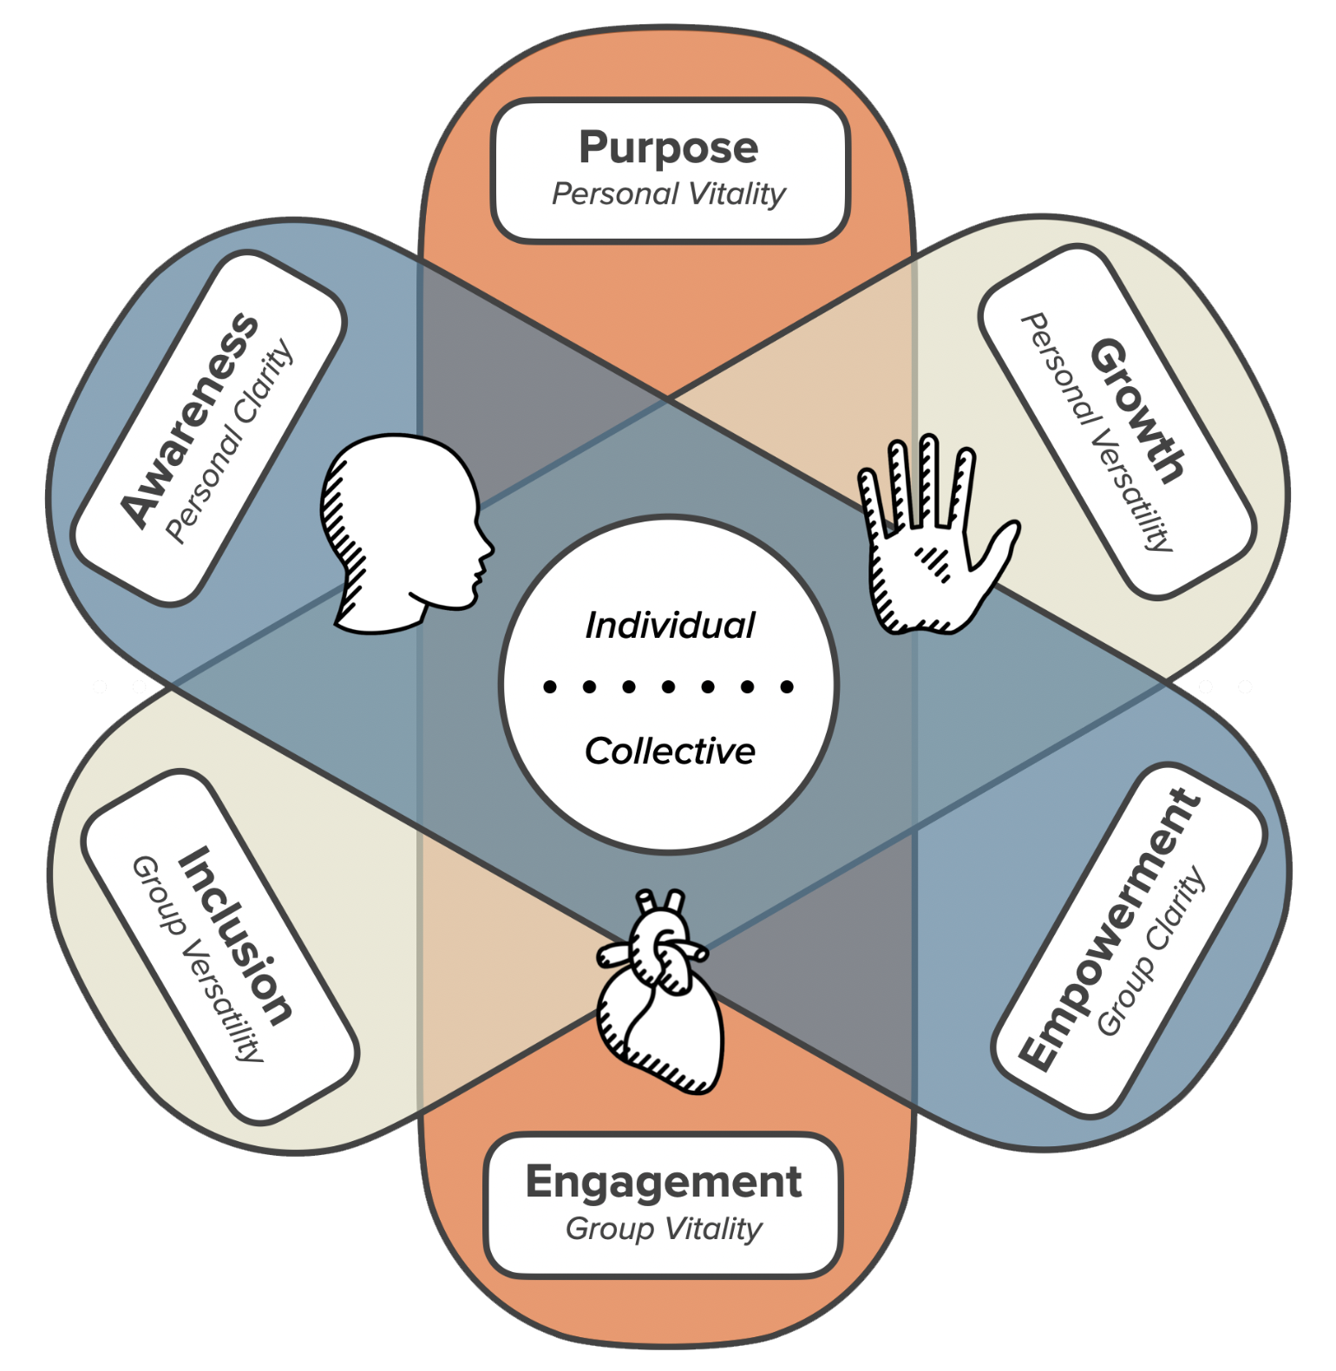

The Humanist’s Leadership Model (2022) is grounded in the literature of  
leadership, human motivation, and wellbeing

Ultimately, we'll work together to develop the knowledge and skills you need to be a humanizing and impactful leader in your workplace. We'll practice with a set of tools you can use to better equip yourself, your peers, your teams, and your organization to survive and thrive in today's VUCA world.

**LEARNING OBJECTIVES**

In this course, we will pursue five primary learning objectives:

* **Explore** the science of leadership, human performance, and wellbeing in mission-driven organizations.
* **Engage** with classmates to inspect your workplace experiences, spark fresh insights, and learn with and from each other
* **Apply** the insights of science and experience to improve your leadership, work performance, and wellbeing
* **Experiment** with new leadership behaviors at home and in the workplace
* **Develop** a grounded assessment, compelling vision, and path forward for the leader you want to become.

**COURSE FRAMEWORK**

Our course framework is built on the Humanist’s Leadership Model. Each of our modules and live class sessions will engage with one component of the model, while creating opportunities to review the empirical evidence, consult the group’s collective experience, and build new awareness and skills

| **CLARITY** | **VITALITY** | **VERSATILITY** |
| --- | --- | --- |
| **Personal & Interpersonal Leadership** | | |
| **Class #1 | Awareness**  Enhancing Self-Awareness & Personal Vision | **Class #2 | Purpose**  Supercharging Energy & Motivation | **Class #3 | Growth**  Developing Full-Spectrum Leadership Skills |
| **Team & Organizational Leadership** | | |
| **Class #5 | Empowerment**  Creating an Empowered Organization | **Class #5 | Engagement**  Inspiring a Highly-Engaged Workforce | **Class #4 | Inclusion**  Building a Culture Where Diversity Shines |

**COURSE SCHEDULE & PREPARATION**

The suggested time needed to prepare for graduate-level courses is a minimum of 2-3 hours outside of class for every hour in class. This class meets for 18 hours in class, so the recommendation is 36-54 hours of work outside of class.

That being said, it’s understood that you are busy adult learners who are balancing many priorities in your lives. With that in mind, I did my best to keep the workload at the lower end of that range, and to make preparation requirements clear and convenient. For example, you’ll notice a bias toward audio content that can be consumed in the car, on the treadmill, or generally on the go. Enjoy it, and please come to class prepared.

Everything you need is available in our Canvas course site:

| **Class #1 (March 7) – Enhancing Self-Awareness & Personal Vision** |
| --- |
| **Pre-Work** (estimated 2.5-3 hours of effort):   * Class #1 Overview * Leading with Clarity * Where Mindfulness & Emotional Intelligence Meet * Implications for Developing Clarity * An Enduring Leadership Lesson: Know Thyself * Know Thyself Reflection * From Self-Narrative to Self-Awareness * Self-Narrative Exercise   **Post-Work** (estimated 1 hour of effort):   * Insights You Can’t Afford to Forget * Core Values Exercise |
| **Class #2 (March 14) – Supercharging Energy & Motivation** |
| **Pre-Work** (estimated 2-2.5 hours of effort):   * Class #2 Overview * Leading with Vitality * Manage Your Energy, Not Your Time * Energy Audit & Reflection * Improving Energy Through Impactful Habits   **Post-Work** (estimated 1.5 hours of effort):   * Insights You Can’t Afford to Forget * Higher Purpose Exercise |
| **Class #3 (March 21) – Developing Full-Spectrum Leadership Skills** |
| **Pre-Work** (estimated 1.5-2 hours of effort):   * Class #3 Overview * Leading with Versatility * Your Leadership Skills * Building a Class Profile * Our Shared Strengths & Values * Our Opposing Strengths & Values * Exploring the Michigan Model * Five Strategies to Develop Skills & Capabilities * Leadership Strengths Exercise   **Post-Work** (estimated 1.5-2 hours of effort):   * Insights You Can’t Afford to Forget * Leadership Behavior Experiment #1: Design * Leadership Behavior Experiment #2: Results |
| **Class #4 (March 28) – Building a Culture Where Diversity Shines** |
| **Pre-Work** (estimated 2.5-3 hours of effort):   * Class #4 Overview * Leading Diverse Teams & Organizations * Inclusive Leadership * Becoming an Inclusive Leader * Building a Culture of Openness & Trust   **Post-Work** (estimated 1.5-2 hours of effort):   * Insights You Can’t Afford to Forget * Leadership Behavior Experiment #2: Design * Leadership Behavior Experiment #2: Results |
| **Class #5 (April 4) – Inspiring a Highly-Engaged Workforce** |
| **Pre-Work** (estimated 2.5 hours of effort):   * Class #5 Overview * Leading Engaged Teams & Organizations * Increasing Engagement by Reinventing Organizations * What Has Been Your Experience? * Becoming an Organizational Artist * Job Crafting Steps 1 & 2   **Post-Work** (estimated 2 hours of effort):   * Insights You Can’t Afford to Forget * Job Crafting Steps 3 & 4 |
| **Class #6 (April 11) – Creating an Empowered Organization** |
| **Pre-Work** (estimated 2-2.5 hours of effort):   * Class #6 Overview * Civil Rights Movement Video Case   + Martin Luther King & His “I Have a Dream” Speech   + Diane Nash & the Freedom Riders   + Bayard Rustin & the March on Washington   + Rosa Parks & the Montgomery Bus Boycott   + Septima Clark & Citizenship Schools   + Ella Baker, the SCLC & the SNCC   + Robert Moses & the Freedom Summer   + Summing Up Your Key Takeaways * Becoming an Empowering Leader   **Post-Work** (estimated 3-4 hours of effort):   * Insights You Can’t Afford to Forget * Survey & Course Evaluation * Leadership Action Plan |

**COURSE DELIVERABLES & EVALUATION**

There are four categories of deliverables for this course. Details are available on the assignments page of our course site. The expectation is that you complete work on time and submit it via Canvas. The deliverables are:

| **Summary Table** | **Points** |
| --- | --- |
| Class Participation (6 class periods) | 36 |
| Module Participation (25 assignments) | 44 |
| Leadership Labs (8 assignments) | 80 |
| Leadership Action Plan (1 assignment) | 40 |
| Total: | 200 |

**DETAILS**

* **Class Participation (6 class periods, 36 points)**Please come to class ready to participate actively, discuss the assigned course materials, and relate them to topics and exercises in class. You should treat live sessions as you would a work meeting with senior management: prepare, attend, and participate. Effective class comments may address questions raised by others, integrate material from this and other courses, draw on real-world experiences and observations, or pose new questions to the class. Class contribution also involves knowing when to speak and when to listen.
* **Module Participation (25 assignments, 44 points)**Throughout Canvas modules for this course, you will be asked to complete small quizzes, brief reflections, and class discussions.
* **Leadership Labs (8 assignments, 80 points)**You are asked to complete four reflective assignments and two 2-part behavior experiments, all of which will be described and assigned in class. These are an opportunity to apply class learning by (a) reflecting on yourself and your leadership, (b) experimenting with new behaviors at work and home, then (c) reflecting on your results to crystalize learning.
* **Leadership Action Plan (1 assignment, 40 points)**The Leadership Action Plan is designed to help you develop and begin moving toward a vision for the leader you want to become. During the course, you will engage with the Humanist’s Leadership Model, review research, and generate new insights by consulting the group’s collective experiences. You will reflect to enhance self-awareness and experiment to develop new skills. This assignment is an opportunity to integrate and apply that work in a 5-7 page paper (12-point font, double spaced) that looks toward the future.

**INSTRUCTOR BIO**

Brian Flanagan is founder and principal at the Water’s Edge Leadership Institute, a leadership learning and development company that serves clients on five continents. As a facilitator and certified professional coach, Brian helps high-potential and seasoned leaders grow, advance, and reinvent.

Brian has deep roots in higher education and a passion for supporting emerging leaders. At the University of Michigan, he is Lecturer in Management and Organizations for the Ross School of Business and Ford School of Public Policy. He teaches courses on leading people and organizations, human behavior in organizations, coaching and mentoring in organizations, and leadership skills for mission-driven organizations. He facilitates leadership development within the business school’s signature action-based learning courses, including Multidisciplinary Action Projects (MAP) and the Living Business Leadership Experience (LBLE).

Brian is also co-developer of the Michigan Model of Leadership (2013), and an executive leadership coach in Michigan Ross’s Executive MBA Program

For 8 years (2012-20), Brian served as Founding Managing Director of the University of Michigan’s Sanger Leadership Center. In that role, he collaborated with key faculty and staff to grow a startup initiative into one of the top leadership centers in the world for broad and deep impact in the lives of college students. His team advanced experiential approaches to leadership development that have been replicated by leading universities in the United States and Europe. Along the way, it developed and launched popular initiatives that are rated among the university’s most impactful, including Leadership Crisis Challenge, Story Lab, Legacy Lab, and the Ross Leaders Academy.

Beyond the University of Michigan, Brian co-developed Homerton Changemakers at Cambridge University in the UK, and spent nearly a decade collaborating to build the Hauenstein Center for Presidential Studies and Cook Leadership Academy at Grand Valley State University.

**Ford Standard Required Syllabus Statements**

**Ford School Inclusivity Statement**

Members of the Ford School community represent a rich variety of backgrounds and perspectives. We are committed to providing an atmosphere for learning that respects diversity. While working together to build this community we ask all members to:

* share their unique experiences, values and beliefs
* be open to the views of others
* honor the uniqueness of their colleagues
* appreciate the opportunity that we have to learn from each other in this community
* value one another’s opinions and communicate in a respectful manner
* keep confidential discussions that the community has of a personal (or professional) nature
* use this opportunity together to discuss ways in which we can create an inclusive environment in Ford classes and across the UM community

**Ford School Public Health Protection Policy**

In order to participate in any in-person aspects of this course--including meeting with other students to study or work on a team project--you must follow all the public health safety measures and policies put in place by the State of Michigan, Washtenaw County, the University of Michigan, and the Ford School. Up to date information on U-M policies can be found [here](https://campusblueprint.umich.edu/). It is expected that you will protect and enhance the health of everyone in the Ford School community by staying home and following self-isolation guidelines if you are experiencing any symptoms of COVID-19

**Student Mental Health and Wellbeing**

The University of Michigan is committed to advancing the mental health and wellbeing of its students. We acknowledge that a variety of issues, both those relating to the pandemic and other issues such as strained relationships, increased anxiety, alcohol/drug problems, and depression, can directly impact students’ academic performance and overall wellbeing. If you or someone you know is feeling overwhelmed, depressed, and/or in need of support, services are available.

You may access counselors and urgent services at [Counseling and Psychological Services](https://caps.umich.edu/) (CAPS) and/or [University Health Service](https://www.uhs.umich.edu/mentalhealthsvcs) (UHS). Students may also use the Crisis Text Line (text '4UMICH' to 741741) to be connected to a trained crisis volunteer. You can find additional resources both on and off campus through the [University Health Service](https://uhs.umich.edu/stressresources) and through [CAPS](https://caps.umich.edu/article/um-mental-health-resources).

**Accommodations for Students with Disabilities**

If you believe you need an accommodation for a disability, please reach out to U-M [Services for Students with Disabilities](https://ssd.umich.edu/) (SSD) office to help determine appropriate academic accommodations and how to communicate about your accommodations with your professors. Any information you provide will be treated as private and confidential.

**Academic Integrity**

The Ford School academic community, like all communities, functions best when its members treat one another with honesty, fairness, respect, and trust. We hold all members of our community to high standards of scholarship and integrity. To accomplish its mission of providing an optimal educational environment and developing leaders of society, the Ford School promotes the assumption of personal responsibility and integrity and prohibits all forms of academic dishonesty, plagiarism and misconduct. Academic dishonesty may be understood as any action or attempted action that may result in creating an unfair academic advantage for oneself or an unfair academic advantage or disadvantage for any other member or members of the academic community. Plagiarism involves representing the words, ideas, or work of others as one’s own in writing or presentations, and failing to give full and proper credit to the original source. Conduct, without regard to motive, that violates the academic integrity and ethical standards will result in serious consequences and disciplinary action. The Ford School's policy of academic integrity can be found in the [MPP/MPA](https://www.dropbox.com/s/oxbgig3kw5dwjzy/FINAL%202022%20Masters%20Handbook.pdf?dl=0), [BA](https://www.dropbox.com/s/i3eiituwsblsncc/FINAL%202022%20BA%20Handbook.pdf?dl=0), and [PhD Program](https://www.dropbox.com/s/31d5lihoviiloqs/FINAL%202022%20PhD%20Handbook.pdf?dl=0) handbooks. Additional information regarding academic dishonesty, plagiarism and misconduct and their consequences is available at: <http://www.rackham.umich.edu/current-students/policies/academic-policies/section11#112>

**Use of Technology**

Students should follow instructions from their instructor as to acceptable use of technology in the classroom, including laptops, in each course. All course materials (including slides, assignments, handouts, pre-recorded lectures or recordings of class) are to be considered confidential material and are not to be shared in full or part with anyone outside of the course participants. Likewise, your own personal recording (audio or video) of your classes or office hour sessions is allowed only with the express written permission of your instructor. If you wish to post course materials or photographs/videos of classmates or your instructor to third-party sites (e.g. social media), you must first have informed consent. ***Without explicit permission from the instructor and in some cases your classmates, the public distribution or posting of any photos, audio/video recordings or pre-recordings from class, discussion section or office hours, even if you have permission to record, is not allowed and could be considered academic misconduct.***

**Please review additional information and policies regarding academic expectations and resources at the Ford School of Public Policy at:** [**https://intranet.fordschool.umich.edu/academic-expectations**](https://intranet.fordschool.umich.edu/academic-expectations)